Semester Project

SDU Sønderborg 2023 Semester 1

*Mubashrah Saddiqa* [*msad@mmmi.sdu.dk*](mailto:msad@mmmi.sdu.dk)

August 14, 2023

Chapter 1

1. The semester project

The semester project is about program development. The project is problem-oriented and the program development is object-oriented. The project work is guided by a problem that the project groups themselves choose and formulates within the framework set out during the semester. In object-oriented program development, work is done to find a solution for a problem through object-oriented analysis and design and to implement this solution in an object-oriented programming language. The project is based on the course "Object-oriented programming", which you implement in parallel with the project.

# The scope of the project

The project is a free project with the following limitations:

1. The problem must be within Our Sustainable Development Goals.
2. The solution must be built upon World of Zuul.

Furthermore, the project must adhere to the specific requirements outlined in section 1.7.

## Our Sustainable Global Goals

The board of SDU approved on 17 June 2019 that the UN's 17 global goals1, mover will be SDU's compass for the university's work. Under the heading "our world goals”2 . SDU will therefore work purposefully and dedicatedly with the global goals throughout the organization.

In the project, you are required to develop a software program that contributes to achieving one or more of the Sustainable Development Goals. Your software program must therefore be a solution that helps alleviate one of the issues addressed by the Sustainable Development Goals.

## World of Zuul

World of Zuul is a game developed by Michael Kölling and David J. Barnes. World of Zuul is modeled after the adventure game 'Colossal Cave Adventure', which was developed in the early 1970s by Will Crowther and Don Woods. Cave Adventure was a grand game that contained the most incredible underground world of caves, passages, and shafts filled with wonderful treasures, dwarves, and lots of magic. In contrast, World of Zuul is an entirely simple game, completely devoid of magic. The game includes rooms and gameplay commands, and it essentially allows a player to move around in 5 rooms and give text-based commands. World of Zuul is waiting for your great ideas and to be developed!

Project groups will be provided with the source code of the game and will further develop 'World of Zuul' based on the provided code, their own problem formulation, and ideas for solutions.

# Inspiration

## Problem statement

Examples of problems that your project could be about:

1 https://[www.verdensmaalene.dk/maal](http://www.verdensmaalene.dk/maal)

2 https://[www.sdu.dk/da/voresverdensmaal/verdensmaaleneogbaredychtigdepaasdu](http://www.sdu.dk/da/voresverdensmaal/verdensmaaleneogbaredychtigdepaasdu)

### Sustainable management and use of water resources in South Africa

South Africa faces growing demands to deal with environmental, social and economic challenges in a holistic and sustainable way. One of the most important challenges is the sustainable management and use of water resources. In a time of increasing water scarcity and pressure and demand after water from all parts of society, water will be an important resource for development and to lift the most marginalized groups out of poverty.

### Reduction of strain on nature and limitation of expensive raw materials

We consume electronics like never before, and electronics are one of the world's fastest growing waste fractions. Worldwide, according to the UN, we are throwing away just under 50 million tons of electronics per year. And the curve just keeps going with rising. Every year we throw away large quantities of electronic devices out (household appliances, flat screens, computers, batteries, cars etc.). A large part of these devices or their components can be easily recycled. In this way, we can reduce the strain on nature and limit consumption of expensive raw materials.

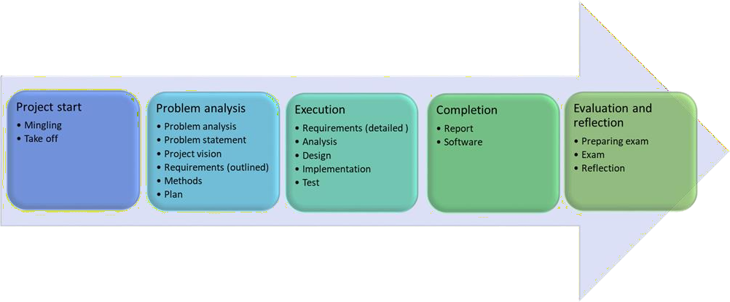

Figure 1.1: Project Phases

## Solutions

Your ideas for solutions can go in several directions: Learning games, gamification or something completely different. The basic solution structure just needs to be one person or something that moves through different locations using commands.

## The inspiration box

See more in the inspiration box (section 1.8).

# Project phases

The project runs throughout the semester from start to finish. The project is divided into five main phases: "Project start", "Problem analysis", "Execution", "Completion”, and "Evaluation and reflection". The phases are shown in Figure 1.1:

The detailed content of the phases can be found in the assignments on itslearning. The time frame for the project is set in the semester plan.

# Work and Cooperation

The scope of the project is 10 ECTS points. This corresponds to 1/3 of the total effort in a semester, or that you each have a work effort of 250-300 hours on the project. Wednesday is fixed project day, where the group has a project workspace at their disposal all day. In addition to the fixed day, the project group can themselves schedule other times for the project work.

In the project group, you draw up a cooperation agreement early in the project process describes how the work and collaboration must take place. A group logbook is written throughout the entire project process. Group logbook contains agendas and meeting minutes of all meetings, including internal meetings, events across project groups and guidance meetings.

# Project guidance

Each project group has a project supervisor. Guidance takes place at guidance meetings and at events across project groups. Guidance meetings and events take place on the fixed project day. The project group works early during the course of the project on a guidance agreement that describes the form and content of the guidance, meetings, written presentations and timetable for the project.

# Project Tools

## IDE

IDE or "Integrated Development Environment" is the tool used to work with software development in the project, including code writing, as well as troubleshooting and testing of program code. You will get instruction in creating code projects and reviewing different types of code projects, using code editors, running code, debugging, and testing during the programming lessons.

## GitHub

GitHub is used for storing code on a development project. GitHub allows version control of the code and supports collaboration. GitHub is also used for the group logbook (wiki) and to provide an overview of the group members' efforts (insights). GitHub logging is introduced at the beginning of the semester in connection with programming lessons.

## Communications tools

There are no requirements for what is used to communicate the project, but there are several good options. The university provides Office 365 for free. Office 365 can be used for creating documents and presentations, including posters. In Office 365, you can share documents with others and collaborate on writing documents together. Alternatives to Office 365: Google "office" (docs, sheets, drive) and LATEX. Experience with the LATEX system will pay off when you reach the final assignment of the education.

# Appendix 1: Specific Requirements

## Specific requirements for the project

* **The project must be built around the provided source code for the game "The World of Zuul".** The game in the provided source code is very simple. It implemented functionality only allows for a text- based input, where you as a player have the option to move around in 5 rooms.
* **The provided source code should be explored as part of the problem analysis.** The exploration should be included in the project foundation. The delivered source code must be expanded during the implementation phase.

The source code must at least be extended by

* Several rooms/locations
* Movement between rooms
* Objects in the rooms
* More commands
* Functionality depending on problem formulation
* Text-based user interface (part 1)
* Layering of classes, as well (part 2)
* Items of your choice
* **Sharing code:** Everyone in the group must have access to the group's code and you must be able to manage different editions (versions) of the different classes. You must use GitHub for sharing the code and as a version control tool.

## Ideas for Expanding the Basic Game

Ideas for you to consider:

* To have objects that can be picked up and others that cannot, and if necessary be a limited capacity for the user regarding how many objects can be collected simultaneously.
* To have an achievable outcome and a situation that indicates the achievement of the result. Winning, and possibly losing. Passing, or not passing. Or...
* To have multiple characters (person, monsters, guide, doctor, or similar) that can move between rooms and that the user can interact with.
* To have a point system, so that points are awarded based on how well one has performed and how far one has progressed.

## Requirements for the project process

The implementation phase must have two parts. The following focus areas should be present in the two parts:

### Part 1 - basic expansion of the provided source code

* 1. Several rooms/locations
  2. Movement between rooms
  3. Objects in the rooms
  4. More commands
  5. Basic functionality depending on problem formulation
  6. Text-based user interface
  7. Items of your choice

### Part 2 - Expansion and refinement of the result from the first part course

* 1. More functionality
  2. Stratification of classes
  3. Items of your choice such as quests, NPCs, a win condition or an inventory system

# Appendix 2: The inspiration box

## Statistics on Global Development (Gapminder.org)

Gapminder is a non-profit company - a modern "museum" on the Internet- which promotes sustainable global development and the achievement of the UN's global goals. Gapminder's goal is to counter destructive misunderstandings about global development through the production of educational resources that make the world understandable based on reliable statistics. Gapminder promotes a fact-based picture of the world

that everyone can understand. Start your exploration of Gapminder with a TED talk where statistics guru Hans Rosling punctures myths about the so-called "developing countries":

<https://www.ted.com/talks/hans_rosling_the_best_stats_you_ve_ever_seen>

See examples here of gapminder's presentation of facts: [https://www.gapminder.org/tools/#$chart-type=bubbles&url=v1](https://www.gapminder.org/tools/#%24chart-type%3Dbubbles%26url%3Dv1)

## Global Citizen (globalcitizen.org)

Global Citizen was founded in 2008. It has since grown into a global movement, engaging millions of people around the world in its mission to address pressing global challenges. Global Citizen addresses the United Nations' Sustainable Development Goals (SDGs) by advocating for policies and actions that tackle global challenges. This includes promoting education, healthcare, gender equality, clean energy, climate action, and more. The purpose of Global Citizen's campaigns is to raise awareness, mobilize collective action, and drive positive change on critical global issues. Through campaigns, events, and partnerships, Global Citizen strives to create a world with no poverty, hunger, or inequality, while fostering sustainable development and global cooperation.

Read more here: <https://www.globalcitizen.org/en/>

## SDU

* **The UN's sustainable goals 1.1.1**

## Project example: Illegal logging: Development of a learning game

When trees are illegally felled, it can have extensive negative economic, environmental, and societal consequences. Illegal logging results in lost revenue, undermines legal businesses, and can have serious environmental impacts such as loss of biodiversity and greenhouse gas emissions affecting the climate.

CLIM is an NGO (Non-Governmental Organization), among other things, aimed at disseminating knowledge about logging and currently shares information through their website. CLIM aims to have a more effective dissemination of knowledge about logging, illegal tree felling, and its consequences, in order to increase awareness about the options individuals have to influence development, for example, through the purchase of certified wood.

* + - 1. *Problem formulation*

|  |  |
| --- | --- |
| Problem: | Development of a learning game that provides knowledge about the options individuals have to adopt to affect the development of illegal logging. |
| Problem formulation: | How can CLIM improve knowledge about the options available to individuals to influence the development of illegal logging through the development of a learning game? |
| Sub questions | What is CLIM?  How does CLIM convey knowledge about logging, consequences and options for action?  What is logging?  What is legal and illegal logging?  What are the consequences of illegal logging? |

|  |  |
| --- | --- |
|  | What action options does the individual have? What is a learning game?  How can we improve knowledge about logging, consequences and action options in a learning game?  How a learning game can be developed? |

* + - 1. *Game Idea*

A learning game, Lumber Jacket, is being developed. In the game, the user can choose between felling illegal and certified trees, and the user has the option to plant new trees as mature trees are felled. The user receives information through a radio channel that describes the impacts of tree felling on the environment. The game demonstrates that we humans can make an active choice, as the user can shape and influence the game themselves.